DNN ISSUE FIX: CANNOT UPLOAD IMAGES VIA HTML EDITOR, OPTIONS GRAYED OUT.
Summary: This issue is caused by bad permissions in DNN’s database for the “Administrators Role” or roleID 0. (This may vary depending on the DNN instance, role 0 is the common role for the RoleName, see that RoleID 0 is assigned to PortalID 0, so if you’re working with multiple portals, this may be a bit different. Just keep all this in mind.
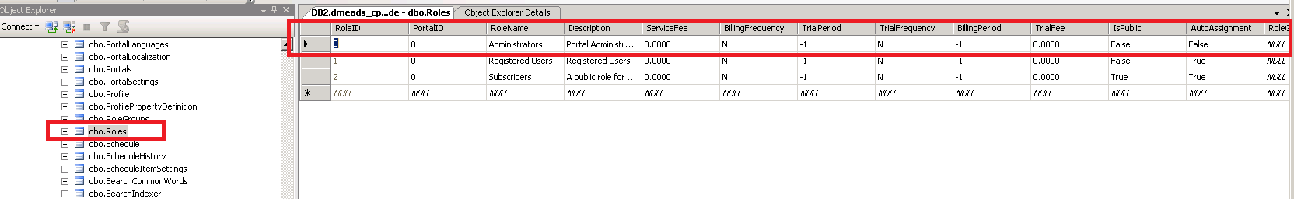

So, if you think about it, when you cannot upload to a folder in DNN and the permissions aren’t caused by server side permissions(IWPD User) the issue could be with the DNN instance. So I’ve checked out two tables: dbo.Folders and dbo.FolderPermission.
Here is the Folders table:
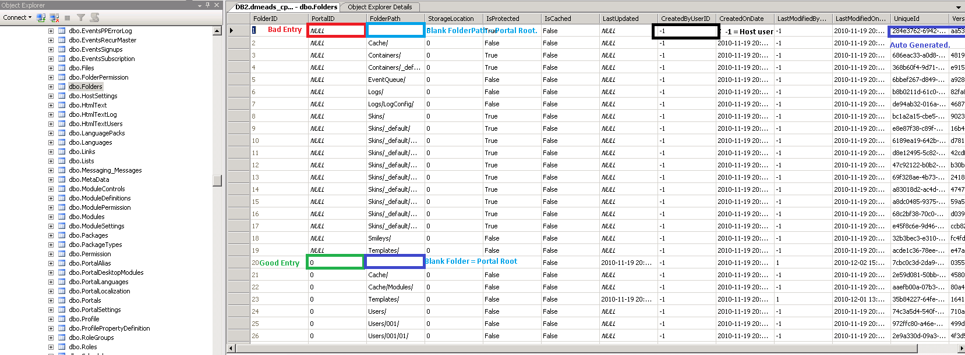

This will require a bit of an explanation if you are not familiar with relational databases.
- FolderID is the Primary Key for this table, it outlines which folders belong to which folder along with other paramaters, like who last updated the folder, the date of last modification, storage location, etc…
- FolderID 1 is an example of a BAD entry. The only thing wrong with it is that it doesn’t have a PortalID entry, so this does absolutely no good.
- FolderID 20 is an example of a GOOD entry. Folder path is blank (Means Root Portal folder, or httpdocs/Portals/0) Bellow are some examples of what a good entry should look like if the entry doesn’t exist:
  - PortalID = 0 or the PortalID you are working on.
  - CreatedByUserID = Should always be -1
  - LastModifiedBy = Should always be -1
  - CreatedonDate = Can be any datetime, you can just copy and paste from another field.
  - LastModifiedOn = Can be any datetime, you can just copy and paste from another field.
  - StorageLocation = Should be 0.
  - FolderPath = Blank entry means Root Portal Folder.
  - Last Updated = Can be NULL or any datetime string.
  - IsProtected = This should be TRUE for the Portal root entry.
  - Iscached = False, unless customer has it otherwise entered. (This is what you would want to set it as if the entry isn’t there)
- Next steps require that you know a little bit about the dbo.Permission table. DO NOT EDIT THIS TABLE UNLESS ENTRIES ARE MISSING...
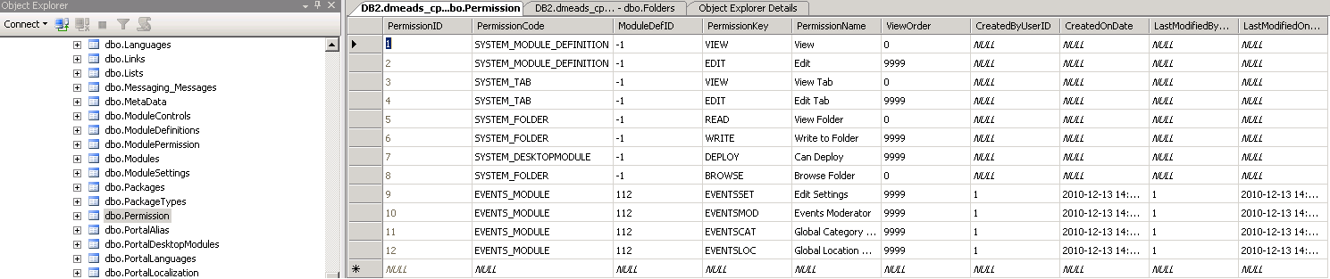
As you can see, PermissionID 5, 6, and 8 are SYSTEM_FOLDER permissions, Portal root is a System folder on DNN. So these are the permissions you will need to keep in mind for this issue:
- 5: SYSTEM_FOLDER: READ
- 6: SYSTEM_FOLDER: WRITE
- 8: SYSTEM_FOLDER: BROWSE
Above 3 permissions are REQUIRED to upload images on DNN or to use the Admin -> File manager functionality, which brings me to the final table: dbo.FolderPermission:
So at this point, we’re looking for FolderID 20. Since that is the good entry on the dbo.Folders table. We want to make sure that FolderID has PermissionID entries of 5, 6 and 8.
You will see 5 entries, 3 for RoleID 0 (Administrators role) and 2 for RoleID -1 (Host/SuperUser Role) The only PermissionID entries the HOST Role needs is 5 and 8. So if you do not see these 5 entries for the folderID you’re looking for, most likely the customer cannot upload images.
Here is what the site would look like with the entries intact when trying to upload images.
If you have a test DNN site and you want to see what this looks like, click on any HTML module on a page and choose Edit Content. (Log in as Admin for best results. Sometimes being a superuser overrides all other permissions, but for some sites it does not.)
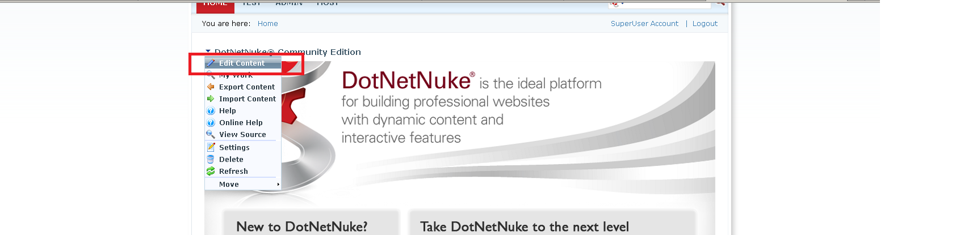
Next, click the “Image Manager” icon: (Shortcut: ctrl +G)
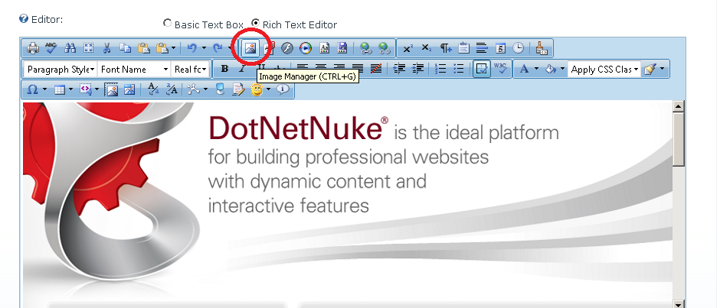
This will launch this window: (As you can see, all the buttons are highlighted and we are able to perform image uploading, etc…)
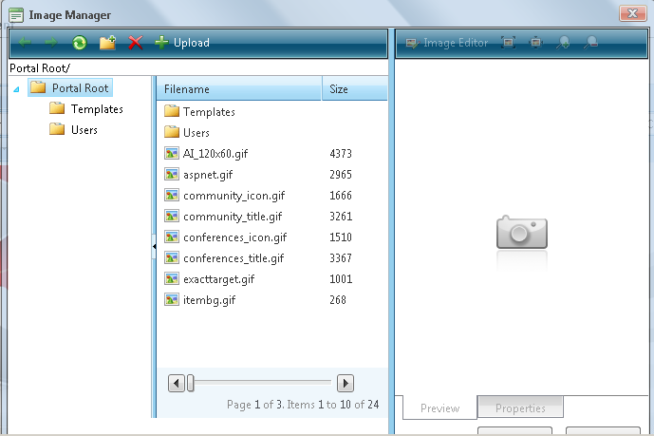
Now, I am going to DELETE the 5 entries that I’ve shown before, and re-launch the image manager to show you what the issue was with the customer’s site:
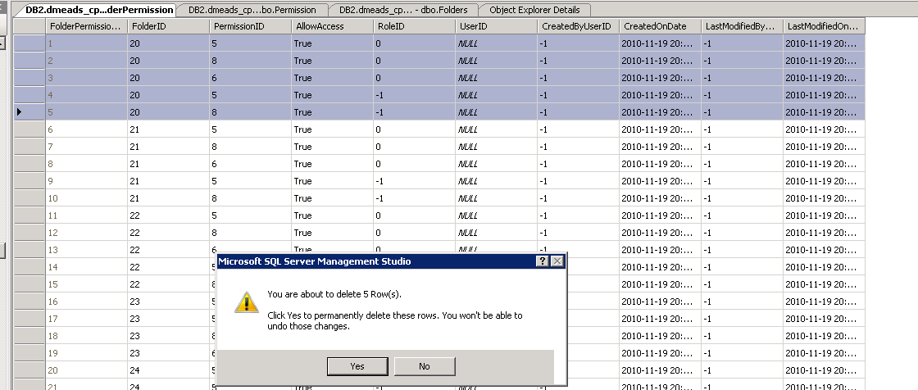
Now that the entries are deleted, I’ve re-launched the Image Manager: (Application Pool needs to be recycled after the rows are added, DNN assigns the permissions to the groups when the application starts up)

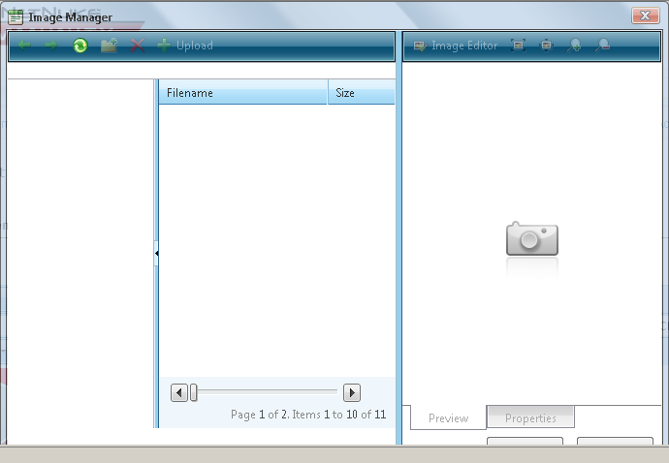
As you can see above, you cannot upload any images or see any images, Now I’ m going to add the entries back: (dbo.FolderPermission)
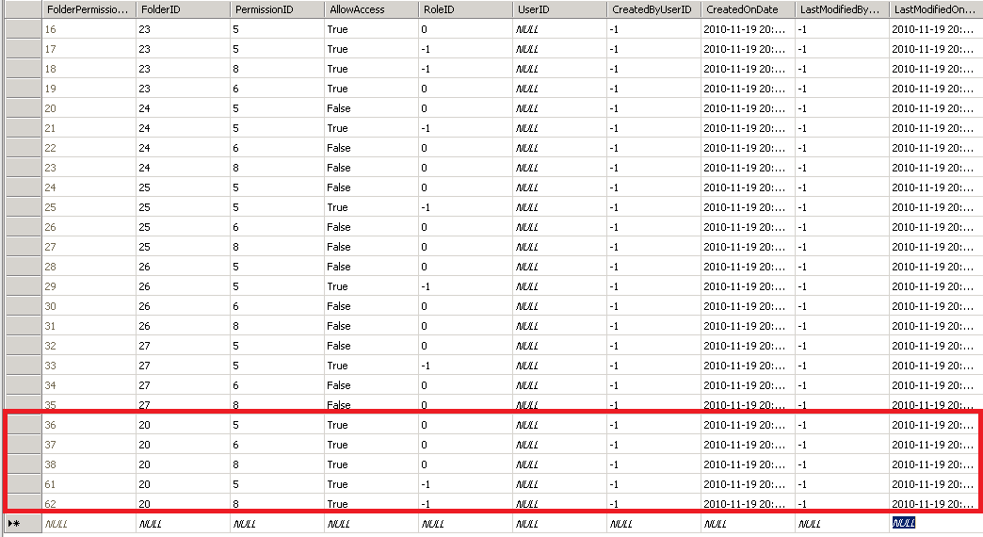
Like, I’ve noted before it does not matter what CreatedOnDate and LastModifiedOn columns are set to, you can just copy and paste from the row above.
Now, this is what I see when I launch the image manager: (Application Pool needs to be recycled after the rows are added, DNN assigns the permissions to the groups when the application starts up)
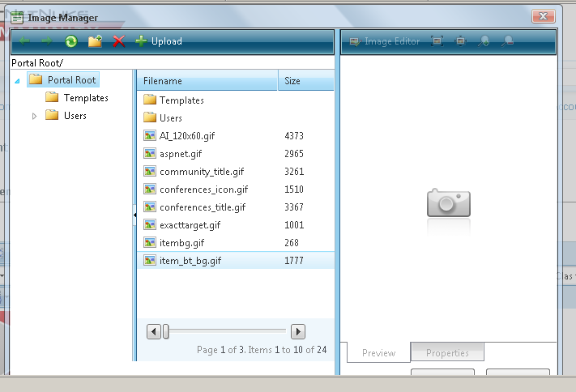

The issue should now be resolved.

